

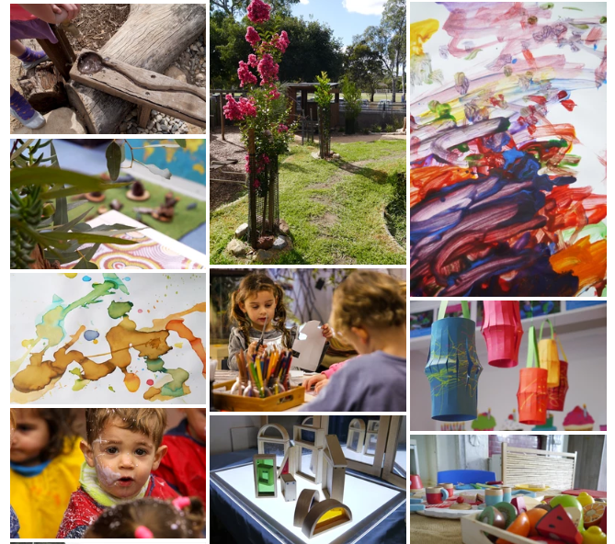

Family Handbook

148 Mackinnon Parade North Adelaide SA 5006 p 8267 2270

e [admin@mackinnonchild.org](mailto:admin@mackinnonchild.org)

w [www.mpccinc.net](http://www.mpccinc.net/)

**Welcome to Mackinnon Parade Children’s Centre**

You and your family are warmly welcome.

This handbook should provide you with adequate information about our Centre so that you can be confident leaving your child at MPCC.

Additionally, Mackinnon Parade Children’s Centre has a website full of useful information and links: Visit [www.mpccinc.net](http://www.mpccinc.net/)

MPCC is a community centre based in North Adelaide with beautiful views of the surrounding parklands accompanied by sounds of the monkeys and the lion from the Adelaide Zoo. We are a registered charity under The Australian Charities and not-for-profits Commission (ACNC). Here at MPCC we have a strong commitment to the provision of high-quality early childhood education and care.

MPCC pride ourselves on our professionalism, our strong working knowledge of the Early Years Learning Framework and the delivery of meaningful programs supported by the loving relationships we have with our children, families, and the community.

Education and Care

Our Centre is approved under National Quality Framework (NQF) - The national benchmark for Early Childhood Education and Care services in Australia.

The key aspect of the National Quality Framework (NQF) are:

* the [National Law and National Regulations](http://acecqa.gov.au/ArticleCategory.aspx?pid=372&gcpid=2)
* the [National Quality Standard](http://acecqa.gov.au/national-quality-framework/the-national-quality-standard)
* an [assessment and quality rating process](http://www.acecqa.gov.au/national-quality-framework/assessments-and-ratings)
* Early Years Learning Framework

*See more at:* <https://www.acecqa.gov.au/>

*Starting Blocks :* <http://www.startingblocks.gov.au>

Starting Blocks provides parents with information about early childhood education and care to help them make the best choice for their child and family *.*

Australian Children’s Education & Care Quality Authority (ACECQA) is the independent national body guiding the implementation of the National Quality Framework (NQF) for Early Childhood Education and Care (ECEC) and ensures consistency in delivery.

**W:** acecqa.gov.au **E:** [enquiries@acecqa.gov.au](mailto:enquiries@acecqa.gov.au) **P**: 1300 422 327

Education Standards Board of South Australia (ESB) is the state body appointed to regulate and assess children’s education and care services within South Australia.

**W:** [www.eecsrsb.sa.gov.au](http://www.eecsrsb.sa.gov.au/)  **E:** [nationalqualityframework@sa.gov.au](mailto:nationalqualityframework@sa.gov.au) **P**: 1800 882 413

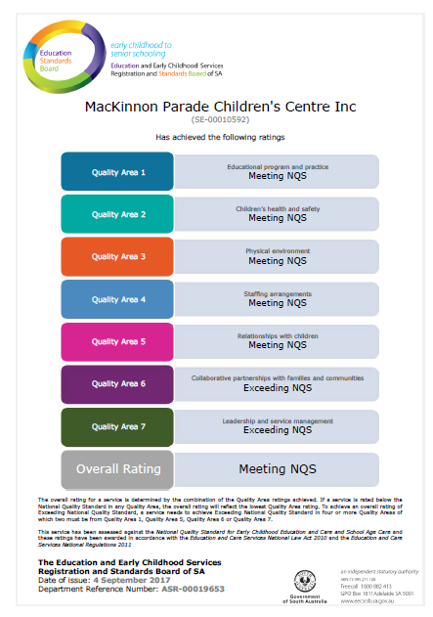The National Quality Standard (NQS)

The seven quality areas covered by the National Quality Standard are:

1. [Educational program and practice](http://www.acecqa.gov.au/Educational-program-and-practice)
2. [Children’s health and safety](http://www.acecqa.gov.au/Childrens-health-and-safety)
3. [Physical environment](http://www.acecqa.gov.au/Physical-environment)
4. [Staffing arrangements](http://www.acecqa.gov.au/Staffing-arrangements)
5. [Relationships with children](http://www.acecqa.gov.au/Relationships-with-children)
6. Collaborative partnerships with families  
    and communities
7. Governance and [Leadership](http://www.acecqa.gov.au/Leadership-and-service-management)

*See more at:* [https://www.acecqa.gov.au/](https://www.acecqa.gov.au/nqf/national-quality-standard)

Quality Improvement

Mackinnon parade Children’s Centre develops a Quality Improvement Plan (QIP) in consultation with a variety of stakeholders. The aim of a QIP is to assess our performance in delivering quality education and care, and to plan future improvements. Please find our QIP displayed in the foyer.

Assessment and Rating

Mackinnon Parade Children’s Centre was assessed and rated against the National Quality Standards in September 2017. We were rated exceeding National Quality in two of the seven quality, also coming very close to exceeding in another two quality areas.

Awarded an overall rating of Meeting National Quality Standards. We stand every proud of our achievements, and through our Quality Improvement Plan you can see MPCC’s passion in striving for exceeding standards across all Quality Areas.

Governance

MacKinnon Parade Children’s Centre Inc. is an Incorporated Body pursuant to the Associations’ Incorporation Act 1991 and the organisation’s constitution.

MC900446010[1]The Board comprises:

* The Chairperson, Treasurer and Secretary, all of whom are parents of our community centre.
* Parent representatives
* The Director
* A staff representative (elected each year by the staff)

The Board is elected at each AGM (Annual General Meeting) and/or voted in at a special meeting during the year if so required.

The Board is committed to supporting MPCC Employees in their role of providing high quality care and education for all children who attend MPCC.

The Board meets on a monthly basis and all parents, volunteers and employees are welcome to attend. The proceedings of board meetings are confidential and if you attend a meeting you are required to maintain confidentiality. Talk to the Director today about attending our next Board meeting.

**How our Centre operates**

Groups

* Caterpillar Room (6 weeks – 1.5 years)
* Monkeys Room (1 year – 2.5 years)
* Giraffes Room (2years – 3.5 years)
* Mackinnon Parade Pre-school (3 years- school age)

The transition from one group to the other is a gradual process. It involves family consultation; regular visits by the child to their new group and the opportunity to be involved in the new group prior to their official enrolment or graduation. Children generally graduate according to their development and wellbeing, wither at the start of the new year or during a mid-year transition.

**Learning Curriculum**Each room within our centre has a child focused emergent curriculum. MPCC’s little community members (the children) thoroughly enjoy exploring all aspects of their learning and development through play-based experiences. MPCC also runs a Pre-School program which also includes a ‘School Readiness’ component.

MPCC thoroughly enjoys exploring our local community, from regular visits to the parklands to excursions to the museum, zoo, art gallery and nature park. Nature brings us endless learning opportunities and our little community members love to explore the nature-based play spaces, mud and all sorts of messy play!

**Opening Hours**

7am to 6pm Monday to Friday

The service is closed on Public Holidays and for 2 weeks over the Christmas/ New Year period. These dates are advised annually.

**Fees**MPCC structures the fees for the service based on annual forecasted budget. The Service is a non- profit organisation, therefore all money received from “fees” is the revenue for the financial operations of the service.

As a non-for-profit organization, the Fee structure of the service is based on, and subject to, the required revenue for the annual operational expenditure.

The Board carefully develops and manages an annual budget resulting in a set fee structure for the service during the given period.

We offer all families a 50% reduced fee rate for 20 days per child/ per year for holidays and planned absences. Please just let us know 4 weeks in advance.

*Please refer to the Fees Policy and Fees Schedule of the Service- this can be found on our website:* <https://www.mpccinc.net/>

**Enrolment**

All enrolments are managed through our active waitlist. From here, potential enrolments are offered to families as a position becomes available within MPCC.

When a potential enrolment is offered to a family, the process undertaken is:

* Families are invited to attend a comprehensive tour of the centre and discuss the individual   
  requirements of your family and/or child as well as our policies, practices and curriculum.
* The next step to secure the enrolment is to complete and return an enrolment form- *your offer of enrolment is not confirmed until this process has been completed and we ask that this is done within 2-5 days after the tour.*
* You will then need to pay the Enrolment fee in full in order to complete the enrolment process. W ask that this is also done within 2-5 days after the tour.
* MC900436151[1]You and your child will then be invited in for several short orientation visits for your child build a sense of belonging within their new environment.
* Contact Centrelink to register or explore your family’s entitlements for Child Care Subsidy (CCS)

**Does your child have additional needs or a medical condition?**

During your Initial tour and enrolment process, it is crucial that you carefully inform MPCC management if your child has serious medical requirements, specialised dietary needs or has a developmental condition. On certain occasions there may be steps to take prior to your child’s commencement to facilitate a seamless transition.

If your child has a Medical Condition, a Risk Minimisation and Communication Plan will be completed and kept up to date in consultation with Mackinnon Management, yourself, the Educators and Staff. This will be completed upon enrolment and kept up to date throughout their attendance. This Plan ensures that children with medical conditions are supported within their environment to ensure any potential risks to their wellbeing are minimised.

In the event that your child requires medication, a *Medication Authority* must be filled in. This allows our Educators to administer medication or apply creams. In the instance that your child is anaphylactic or has a medicated allergy, an approved Action Plan is required alongside the Risk Minimisation and Communication Plan.

For the relevant Action Plan, please visit: <https://www.education.sa.gov.au/supporting-students/health-e-safety-and-wellbeing/health-care-plans>

MC900215255[1]All “over the counter” or non-prescribed medication, creams, lotions and gels etc. require a Medication Authority form signed by a health professional (doctor or pharmacist) and the parent/ caregiver, to accompany the product.

This product must be in the original container, within the “best before” date, however, does not require a prescription or pharmacist label. Please ensure the child’s name is on the container. *\* This excludes paracetamol, Paracetamol will only be administrated under direction of a doctor in the form of a prescription.*

**What does your child need to bring to MPCC?**

Please ensure that your child brings the following:

* MC900237521[1]A sturdy bag like a backpack
* Water bottle
* Change of clothes- several sets when the weather is providing the children endless opportunities (raining!), suitable clothing for outdoor play in the colder months.
* A sun hat – the Centre provides hats approved by the Sun Smart Council at a small fee, parents are welcome to provide their child with a hat that complies with Sun Smart recommendations. Please note that if a child attends the centre without a suitable sun hat the service will automatically supply one, in line with our Sun Protection Policy, and charge the related cost to the family’s account. This ensures no children miss out on out on outdoor play with their friends.
* Dummy and/or comforter (settling teddy/blanket) if applicable
* Bottles if applicable
* Medication or creams if applicable (these must be handed directly to an Educators for safe storage, and under NO circumstances be left in a child’s bag)

Please ensure that all items are labelled with the child’s name to enable us to return items to the correct person, otherwise you may find missed placed items in the lost property box.

**Accidents and serious Illness**

MC900388716[1]Every effort is made to prevent accidents and illness, however, if a child does have an accident or becomes ill, Educators will take the appropriate action. If medical attention is required, every effort will be made to contact the parents or caregiver as soon as practical.

Depending on the severity of the accident or illness, the child will be cared for at the Centre until a family member can come collect them or an Ambulance may be called.

Ambulance Officers will determine if the child should go to hospital. Children in urgent need of medical attention will be taken by Ambulance to the Adelaide Women’s and Children’s Hospital. The Centre will contact the parents or caregiver to advise them about the situation. The Centre has Insurance for Ambulance cover for accidents only. If a child needs to be transported to hospital due to a serious illness, the Centre cannot be responsible or liable for any medical fees or ambulance costs that may be incurred.

Educators and other employees are not authorised to transport children in their own vehicles.

**Sick children**

The Centre has a responsibility to your family, other families and employees to reduce the spread of infection or illness. Therefore, please don’t send your child to MPCC if they are showing signs of illness. Our experience shows that if a child needs medication (including Paracetamol) the night before or the morning of to reduce pain or fever, there is a strong possibility that the symptoms will re-occur during their day. To prevent the need for parents/caregivers to be called away from work or other commitments, you are urged to make alternate arrangement until your child is completely well.

MC900196390[1]If your child becomes ill during the day, the Educators will contact a parent, caregiver or other contact person on the enrolment form. Should no-one be contactable, and the situation becomes a medical emergency, Educators will call an Ambulance.

Our Policies relating to sick children follow the recommendations of “Staying Healthy in Child Care” published by the Australian Government National Health and Medical Research Council. Please refer to the Policies of the service pertaining to Health and illness.

**Anaphylaxis**

We have several children enrolled at the centre who have severe allergic reactions including anaphylaxes to a range of food.

We strongly refuse families to bring any food into the centre from home. If your child has eaten toast with peanut butter for breakfast prior to attending the service, please ensure they thoroughly wash their hands prior to attending.

**Immunisation**

MC900292556[1]As per SA Health requirements, each child is to be up-to-date with their immunisation schedule in order to attend an education and care service. Parents are required to provide MPCC with up-to-date Immunisation History Statements as required. These can be accessed through MyGov- Medicare.

In the instance that a child is not up-to-date or on an approved catch up schedule, the child will be refused care until the requirements are met.

In the event of an outbreak of an infectious disease, the Centre will take advice from the Infection Control Service Section of the Communicable Disease Control Branch in the Department of Health. If this situation arises, parents and caregivers will be kept fully informed.

For more information surrounding immunisation requirements, please visit: <https://www.education.sa.gov.au/supporting-students/health-e-safety-and-wellbeing/immunisation-requirements-early-childhood-services>

**Want to book your child in for an additional day?**

MPCC offers casual day bookings for enrolled families who may require a day of care here or there. These can be arranged over the phone, an email last minute or planned for up to 4 weeks in advance. The casual day is charged at the full rate as well as a surcharge. Please refer to our Fee Schedule for the outlined costs.

If you wish to make adjustments to your child’s permanent bookings, whether it be swapping days or adding an additional day, please email us at [admin@mackinnonchild.org](mailto:admin@mackinnonchild.org). If you’re looking at cancelling a permanent day or enrolment, we will require x4 weeks’ notice in writing (email form).

Please note that we try our very best to give our families the days they require, however, as our centre generally runs at capacity, you may have to go onto the waitlist.

Are you expecting a new family member?

Please see us in the reception and we will be happy to assist you in popping the ‘to be announced’ new family member onto the waitlist.

**Toys from home**

MC900237584[1]We ask that children *do not* bring toys from home. This avoids loss or breakage.

Χ

We have a range of toys and materials at the Centre for the children to use. The only item that your child should need to bring to the Centre is a comfort item e.g. blanket/ teddy/ dummy.

MPCC Crew will ensure that these special items are stored carefully and only used for their intended purposes. In the instance that children bring in resources in accordance with the current curriculum, this will be arranged with the Educators in your child’s room.

**Valuables**

Please be cautious sending your child with valuable items or jewellery. The security of such items cannot be guaranteed.

Χ

**Pram, stroller and car seat etc. storage**

MPCC is unable to provide Pram, Stroller, baby capsules, scooters, bikes etc parking on the premises currently. We have identified the storing of these items in the hallway at the front door as a hazard, at times preventing the front door from being opened effectively.

Unfortunately, we have been unable to identify another suitable location onsite, we therefore request families take these items off site with them after drop off.

We are sorry for this inconvenience however we must place the safety of children and employees above this convenience.

**Children’s Clothing**

Please ensure that all your child’s belongings are clearly labelled with their name. The Centre will take due care but is unable to accept responsibility for lost property. Children are offered a wide variety of activities and experiences at the Centre, some of which are messy. Children are encouraged to wear smocks during messy play, which are provided by the Centre.

We ask that parents dress their children in comfortable clothes and anticipate that they are likely to become dirty during the day. Please ensure that your child has spare sets of clothes in their bag.

When your child is toilet training you may need to pack more than one change of clothes. Please also dress your toilet training child in clothes that are easy for them to put on and take off.

**Footwear**

MC900351201[1]Please ensure that your child has footwear that is comfortable for running and climbing. Footwear that is not fitted correctly to a child’s foot can cause them to trip. If this occurs at the Centre, your child’s footwear may be removed to avoid further injury. We do not consider thongs to be adequate footwear.

If your child wears rubber boots during the winter months, please also provide alternative shoes they can wear inside.

MPCC encourages barefoot play within our indoor and outdoor environments as it promotes children’s physical growth and development.

**Sun Protection Policy**

MC900446274[1]The Centre incorporates a Sun Smart principle, which means our practices follow the guidelines of the Cancer Council. The UV rating is actively monitored between August until the end of April and during this time, with the UV reaching 3 or more, hats and sunscreen are required when children are outdoors.

The purpose of this policy is to ensure that all children attending the Centre are protected from skin damage caused by the harmful ultra-violet rays. Parents/caregivers are required to ensure that they provide clothing with sleeves for their child to wear when they play outside. The Centre can provide suitable hats for all children and will charge the cost of the hat to the families account.

MC900280421[1]MC900303675[1]**Food and nutrition**Our chef, Sheree, prepares fresh meals daily with inspiration of cultural dishes from all around the world! Morning and afternoon teas are seasonal fruit platters and savoury assortments or baked snacks. Lunch is a variety of options including steamed vegetables accompanied by a main meal and wholemeal bread. All meals are freshly prepared on the premises each day.

We do not use pre-packaged or pre-cooked food. Good nutrition is of vital importance to babies and young children. It helps them grow, develop, maintain healthy bodies and establishes a basis for healthy eating habits. MPCC Educators are encouraged to join the children for mealtimes as this emphasises the social aspect to eating.

**Birthday Cakes**

 Birthdays are a special time and here at MPCC we love to celebrate with our little friends, so we invite you to order a birthday cake for your child to share. Due to health and safety requirements we bake birthday cakes on the premises at a cost of $25.00.

To order your child’s cake please email the centre with x2 weeks’ notice prior to the requested date. The cost will be charged to your account.

**Grievances and Complaints**

We value open communication and greatly appreciate your honesty and respect by letting us know immediately if you are not satisfied with any practices or delivery of our services. This will allow us the opportunity to explain the reasons why we have certain procedures, assist us to identify what is important to our families and generally assist us to improve our service.

Please contact the Director at [director@mackinnonchild.org](mailto:director@mackinnonchild.org) as soon as possible as your grievances are of high priority to us.

Please refer to Grievances and Complaints policy for further clarification of our complaints process.

MC900434389[1]**Do you still have questions?**

**??**

We have provided the essential basic information to help make the enrolment process thorough and of ease for you and your child. If you have further questions, concerns or suggestions please call us or email.

Useful resources:   
Parenting SA: <https://parenting.sa.gov.au/>  
Kidsafe: <https://kidsafe.com.au/>  
ReNose: <https://rednose.org.au/section/safe-sleeping>  
Department of Education: <https://www.education.sa.gov.au/>  
Raising Children network: <https://raisingchildren.net.au/>  
Aboriginal Family Support Services: <https://www.afss.com.au/>

Please remember to update your child’s dietary, health, and allergy information as needed.

Please also ensure that you keep us up to date with your contact details.

MPCC Policy & Procedure Folder is available in the front foyer for you to read or refer to at any time.

Our website has useful information and our full list of policies and procedures.

If you have any questions, please feel free to contact us here at MPCC.

Welcome to our community!